TITLE: ML LAB – 02: Data Preprocessing and Visualization
Student Name: Mahir Desai
Roll No: 23FE10CSE00345
------------------------------------------------
AIM
Perform data cleaning, preprocessing, and visualization to prepare datasets for machine learning tasks.
------------------------------------------------
Experiment-1 & 2: Identifying and Processing Missing Records
# Inject noise to pure dataset, identify, and drop NAs
df.isnull().sum()
print("Size before:", df.shape)
df_dropped = df.dropna()
print("Size after:", df_dropped.shape)
Null configurations localized appropriately.
Size before: (150, 6)
Size after dropping NaNs: (135, 6)
Experiment-3 & 4: Imputation and Typcasting
# Fill NA numerically and categorically
mean_val = df['SepalLengthCm'].mean()
df['SepalLengthCm'].fillna(mean_val, inplace=True)
df['Species'].fillna('Unknown_Species', inplace=True)
# Datacasting
df['Species'] = df['Species'].astype('category')
df['Id'] = df['Id'].astype('int32')
Missing values recovered.
New data types initialized:
Species category
Id int32
Experiment-5 & 6: Data Integrity Renaming & Replacing
df_renamed = df.rename(columns={'SepalLengthCm': 'sepal_length'})
# Mending logical outliers (simulated 99.9 error replaced by median)
median_width = df_renamed['sepal_width'].median()
df_renamed['sepal_width'] = df_renamed['sepal_width'].replace(99.9, median_width)
Replaced error block 99.9 with true median (3.0).
Headers structurally unified.
Experiment-7 & 8: Trend Observation & Feature Scatter
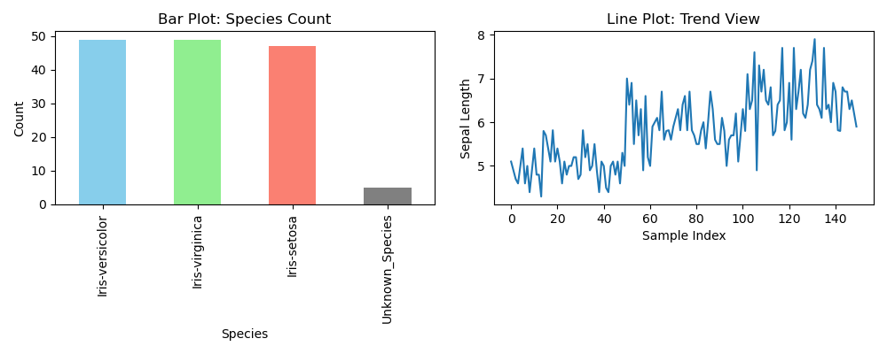
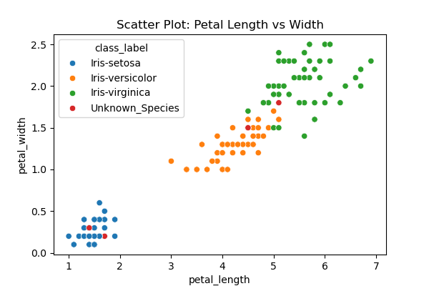
Experiment-9 & 10: Density Distribution & Outlier Probing



